# **UiPath Practical Questions**

**Assignment #1: Unattended BOT process**

**Process Name: Daily Bank File Process for finance team**

Create a folder locally called ‘Technical Test’. Assume attached excel files are provided by business each day. So, this process would be unattended process that runs once daily.

1. Each day, end user downloads the daily transaction file from the bank and places in the folder named :[…\Technical Test\TransactionList\_02082021.xlsx](file:///C:\Users\RPA_User\Desktop\Technical%20Test\TransactionList_02082021.xlsx)
2. Same folder contains […\Technical Test\BankAccount\_Mapping.xlsx](C:\\Users\\RPA_User\\Desktop\\Technical Test\\BankAccount_Mapping.xlsx) which has different bank accounts mentioned in above file mapped to corresponding bank account names in column B, i.e; Vlookup Reference.

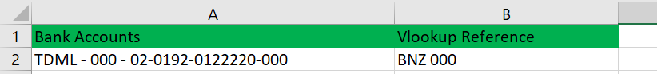

1. Same folder also have another file that has multiple tabs, each tab referencing the bank account names eg: BNZ 000 , BNZ 002 etc.

[….\Technical Test\ Classification\_Mapping.xlsx](file:///C:\Users\RPA_User\Desktop\Technical%20Test\%20Classification_Mapping.xlsx)

**What we expect you to develop?**

1. Split the transactions in ‘TransactionList\_02082021.xlsx’ into 3 different files and have then finally placed to folder….\Technical Test\output
2. Rename the 3 newly created files based on mapping provided in ‘BankAccount\_Mapping.xlsx’. ‘**Vlookup Reference**’ value from the ‘BankAccount\_Mapping.xlsx’ must be used as the file name (eg: BNZ 000.xlsx)
3. Thereafter create a new column called “**Classification**” on all the 3 files.
4. ‘**Classification**’ column should be populated using a VLOOKUP formula with the following logic
   * first use the “**Reference**” column value (in the Split File eg:BNZ 000.xlsx) as the lookup\_key against the ‘**vlookupName’** column (in the Classification\_Mapping.xlsx) to extract the value from ‘**vlookupValue’** column value in same file. The extracted value is what then need to be populated onto the ‘Classification’ column for the split files.
   * if the above lookup\_key is not found, use the “**Code**” column value as the next lookup\_key
   * if the above lookup\_key is not found, use the “**Particulars**” column value as the next lookup\_key
   * if the above lookup\_key is not found, use the “**Other Party**” column value as the next lookup\_key
   * if the above lookup\_key is not found, use the “**?**” as the value to be populated (in the ‘Classification’ column in the split sheet)
5. Once the three new excel workbooks are created, create a pivot table in a new sheet in these three excel workbooks by referring to the columns

|  |  |
| --- | --- |
| ***PivotTable Fields*** | Rows   1. Date 2. Classification |
| Values: Sum of Amount |